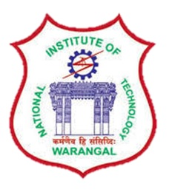

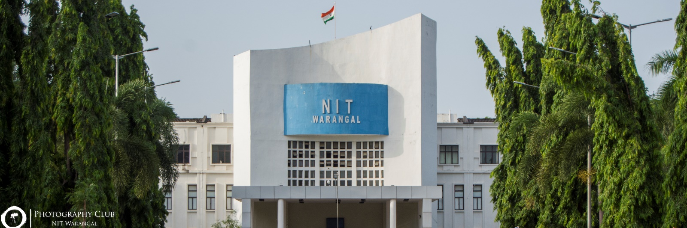

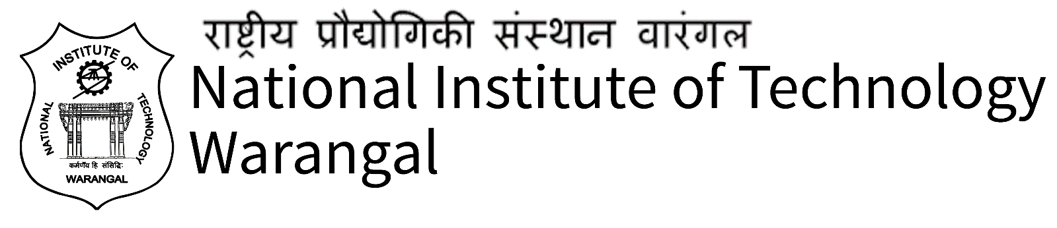

***MISSION-***

* Imparting total quality education to develop innovative, entrepreneurial and ethical future professionals fit for globally competitive environment.
* Allowing stake holders to share our reservoir of experience in education and knowledge for mutual enrichment in the field of technical education.
* Fostering product-oriented research for establishing a self-sustaining and wealth creating Centre to serve the societal needs.

***VISION-***

"Towards a Global Knowledge Hub, continuously in pursuit of excellence in Education, Research, Entrepreneurship and Technological services to the society"

***Rankings-***

* By NIRF in 2018: **25**
* By NIRF in 2017: **34**
* By Outlook India in 2016: **10**
* By Outlook India in 2015: **11**
* By Edu Rand in 2015: **41**
* By the Week in 2015: **15**

**COURSES OFFERED**

|  |  |
| --- | --- |
| **B. Tech** | Chemical Engineering / Civil Engineering / Biotechnology/ Computer Science Engineering / Electrical Engineering/ Electronics and Communication / Mechanical Electrical and Electronics / Metallurgical Engineering |
| **MBA** |  |
| **MCA** |  |
| **MSc** | Analytical Chemistry / Applied Mathematics / Engineering Physics / Mathematics and Computing / Organic Chemistry |
| **M. Tech** | Automobile Engineering / Chemical Engineering / Civil Engineering / Computer Integrated Manufacturing / Computer Science and Engineering / Construction Technology / Electronics and Instrumentation Engineering / Environmental Engineering / Machine Design / Manufacturing Technology / Power Electronics and Driven |
| **PhD** | Chemical Engineering / Civil Engineering / Computer Science and Engineering / Electrical Engineering / Electronics and Communications Engineering / Mechanical Engineering / Biotechnology / Chemistry / Mathematics / Physics |



***Clubs-***

* Nature’s club
* Photography club
* Dance and Drama club
* Literary and Debating club
* Sports club

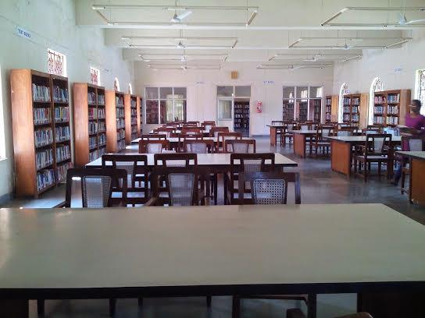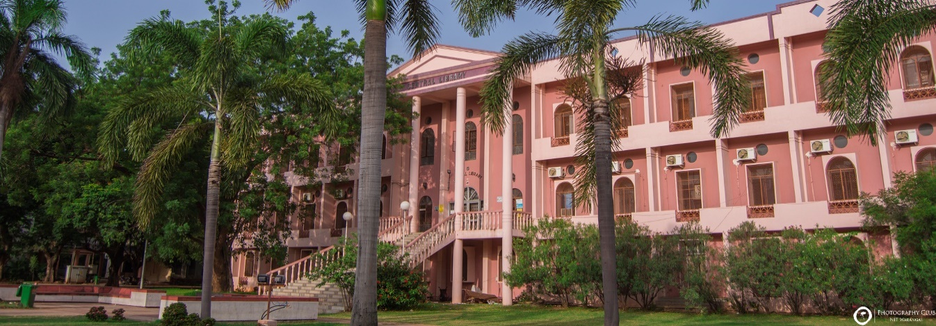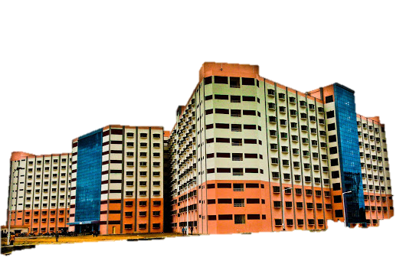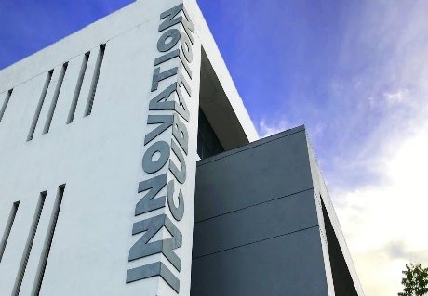

***Facilities-***

* Hostels
* Library
* Digital library
* Internet access
* Sports grounds